2026 Officers
Keith Henry - Chairman
Valerie Myers - Vice Chairman
Chelsey Gallow Hopkins - Secretary
Nicole DeJean-Broussard - Treasurer
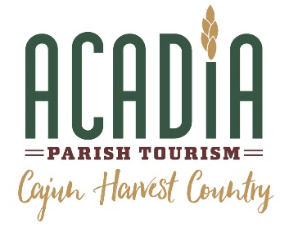
Commissioners
Suzette Leonards
Harold Fonte
Shanteé Gotte Manuel
Chellie Godeaux
Nora Benoit
Bart Wild
Marietta Leonards

Acadia Parish Convention & Visitors Center

June 9, 2026

FOR IMMEDIATE RELEASE
Rayne Named Southeast Regional Winner in Parade’s America’s Favorite Small Towns Competition
CROWLEY, La. — Acadia Parish Tourism is proud to announce that Rayne, Louisiana, has been named a Southeast Regional Winner in Parade Magazine’s 2026 America’s Favorite Small Towns competition, earning national recognition for the community’s unique culture, hospitality, and hometown charm. Parade Magazine will announce the national winner on June 12, 2026. Supporters are encouraged to vote for Rayne at https://parade.com/travel/americas-favorite-small-towns-2026-meet-the-regional-winners
Known as the “Frog Capital of the World” and Louisiana’s “City of Murals,” Rayne offers visitors an authentic Cajun experience through its vibrant public art, rich heritage, local festivals, and welcoming spirit.
“This recognition is a tremendous honor for Rayne and for all of Acadia Parish,” said Chere Ledoux, Acadia Parish Tourism. “People who visit our communities discover something genuine—rich traditions, incredible food, hometown festivals, and neighbors who welcome you like family. Rayne embodies the spirit of Acadia Parish, and we are thrilled to see that spirit recognized on a national level.”
While the designation celebrates Rayne, it also shines a spotlight on the entire parish and the experiences that make Acadia Parish a unique destination. From Cajun music and culture to agricultural heritage, outdoor recreation, and authentic Louisiana cuisine, visitors are invited to explore all that Acadia Parish has to offer.
“We hope this recognition inspires more travelers to discover Rayne and explore the communities, traditions, and hospitality found throughout Acadia Parish,” Ledoux said.
For more information about Rayne and Acadia Parish, visit AcadiaTourism.com.
Media Contact:
Chere Ledoux
Acadia Parish Tourism
(337) 277-7367 - Cell
(337) 783-2108 – Office
chere@acadiatourism.com

